**DAILY ONLINE ACTIVITIES SUMMARY**

|  |  |  |  |  |  |  |  |  |
| --- | --- | --- | --- | --- | --- | --- | --- | --- |
| **Date:** | **28/06/2020** | | | | | **Name:** | **NAIPUNYA VINOD NAIK** | |
| **Sem & Sec** | **IV SEM & A SECTION** | | | | | **USN:** | **4AL18CS050** | |
| **Online Test Summary** | | | | | | | | |
| **Subject** | | **NO INTERNALS CONDUCTED** | | | | | | |
| **Max. Marks** | | **---------------** | | **Score** | | | **----------------** | |
| **Certification Course Summary** | | | | | | | | |
| **Course** | **MICROSOFT POWERPOINT** | | | | | | | |
| **Certificate Provider** | | | **UDEMY** | | **Duration** | | | **4 HRS** |
| **Coding Challenges** | | | | | | | | |
| **Problem Statement: NO PROBLEM STATEMENT GIVEN TODAY** | | | | | | | | |
| **Status: -----------** | | | | | | | | |
| **Uploaded the report in Github** | | | | | **YES** | | | |
| **If yes Repository name** | | | | | <https://github.com/naipunya-naik/daily-progress-report> | | | |
| **Uploaded the report in slack** | | | | | **YES** | | | |

Online Test Details: (Attach the snapshot and briefly write the report for the same)

NO INTERNALS CONDUCTED

Certification Course Details: (Attach the snapshot and briefly write the report for the same).

CERTIFICATION COURSE NAME:- MICROSOFT POWERPOINT

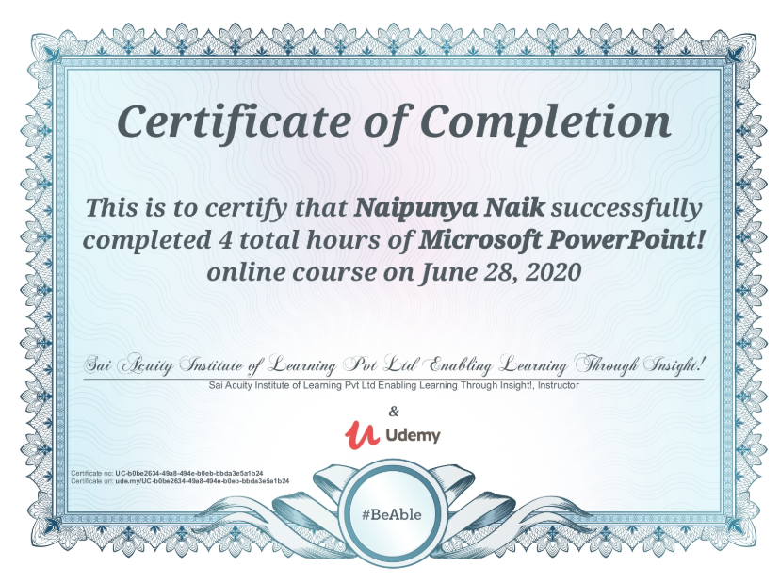

TOPICS LEARNT ON 28 JUNE 2020:-

* Create a Presentation
* Run a Presentation
* Save a Presentation as a Show
* Use different functionalities of PowerPoint
* Create a Table
* Create a Picture and how to enhance them using picture tools
* Use ClipArt and use different media file types
* Use Screenshot, Photo album, and Shapes
* I)Use SmartArt, Charts, and Hyperlinks

Coding Challenges Details: (Attach the snapshot and briefly write the report for the same)

NO PROBLEM STATEMENTS GIVEN TODAY